MULTIFAITH DONATION OPTIMIZER
- Guided by Prof. Ashwini Sengar Mam - Created by Gargey Mahajan,
Abhishek Badave,
Ganesh Deshmukh

1. INTRODUCTION
1.1 Background
Donations are a universal practice found across all major religions — Hinduism, Islam, Christianity, Buddhism, Sikhism, and Judaism. Each faith emphasizes generosity, compassion, and helping the less fortunate as an essential moral duty. Religious teachings have long promoted the value of sharing wealth for the welfare of society. For example, Zakat in Islam, Dāna in Hinduism and Buddhism, Tithing in Christianity, and Seva in Sikhism all express a common belief that giving is an act of faith and moral responsibility.
However, in the modern digital age, the donation landscape has become fragmented. Existing donation platforms usually focus on either faith-based giving (donations made to temples, mosques, churches, or monasteries) or cause-based giving (donations made to social or humanitarian causes such as education, hunger relief, or disaster aid). While both systems are effective in their own way, they rarely interact with one another. This lack of integration creates several problems:
- Inefficiency in resource allocation, as certain causes may receive more attention and funding while others remain underfunded.
- Lack of transparency, since donors often have limited visibility into how their contributions are utilized.
- Reduced social impact, as the full potential of collective donations across diverse faiths and causes is not realized.
To address these challenges, the Multifaith Donation Optimizer was conceptualized as a centralized, technology-driven platform that unites donors, faith-based institutions, and social causes under one digital ecosystem. The platform is designed to ensure that every donation contributes toward maximum social benefit, all while respecting religious principles and donor preferences.
By incorporating modern web technologies — HTML, CSS, and JavaScript — this project bridges the gap between spiritual intention and social execution. The system uses an optimization model that analyzes donation inputs and distributes them fairly among participating organizations, ensuring balanced support across multiple causes and religions. It offers a transparent, easy-to-use interface where donors can visualize how their money is allocated in real time.
1.2 Need and Significance
In recent years, digital philanthropy has experienced significant growth. People increasingly prefer online platforms to make charitable contributions. However, the faith-based giving sector has not kept pace with innovation. Most digital donation platforms remain narrowly focused, supporting only a single religion or a specific NGO. This exclusivity limits opportunities for interfaith collaboration, where collective efforts from diverse religious groups could make a far greater social impact.
Moreover, faith-based organizations are often deeply embedded within communities and possess strong social trust. When their charitable activities align with broader global goals — such as the United Nations’ Sustainable Development Goals (SDGs) — the result is not only moral but also measurable progress in areas like poverty reduction, education, gender equality, and healthcare.
The Multifaith Donation Optimizer project recognizes this potential. It integrates the moral strength of religious giving with the analytical precision of technology, creating a system that promotes both faith unity and social sustainability. Through its transparent donation optimization model, the platform ensures that donor intentions are honored while maximizing the effectiveness of every rupee contributed.
1.3 Motivation
The motivation for this project arises from the realization that faith and social responsibility are not separate domains — they are deeply interconnected. Every religion encourages compassion, service, and equity. Yet, in practice, charitable giving is often divided along faith lines, creating duplication and imbalance in resource distribution.
Our team wanted to build a system that not only respects individual religious sentiments but also transcends them for a common cause — human development. The Multifaith Donation Optimizer thus stands as a symbol of interfaith harmony and technological innovation. It demonstrates how modern tools can amplify the positive impact of ancient values.
The platform provides donors with both ethical confidence and data-driven insight. They can see which faith-based organizations are contributing most effectively toward sustainable goals, and adjust their giving accordingly. This makes philanthropy more conscious, measurable, and impactful.
1.4 Objectives
The main objectives of the Multifaith Donation Optimizer are:
- To develop a centralized donation platform that supports multiple religions and charitable causes.
- To use optimization algorithms in JavaScript that distribute donations fairly and transparently.
- To align donations with SDG indicators such as education, hunger, and healthcare.
- To encourage interfaith collaboration by allowing donors to contribute across religious boundaries.
- To increase transparency and accountability in how donations are allocated and used.
2. The Gap Between Existing Apps
In the current digital landscape, numerous donation applications exist, but most of them serve narrow or single-purpose goals. While they provide convenience for donors within specific religious or organizational contexts, they fail to create a unified system for global, transparent, and optimized giving. The Multifaith Donation Optimizer project was conceived to bridge this technological and ethical gap by offering a platform that harmonizes multi-religious charity practices with modern optimization techniques.
2.1 Limitations of Existing Platforms
- Single-Use Donation Systems: Many current donation platforms are designed for a specific audience or purpose. For example, Zakat-based apps cater exclusively to Muslim donors following Islamic charity rules, while Church tithing platforms are intended for Christian congregations. Similarly, various NGOs and non-profit organizations operate their own independent fundraising apps. While these platforms successfully serve their individual communities, they function in isolation, creating a fragmented ecosystem where donors must use multiple applications to support different causes. This lack of integration limits the overall potential of digital philanthropy.
- Lack of Inclusivity Across Faiths: Another significant shortcoming of existing systems is their exclusivity. Donors are often restricted to contributing within a single faith or organizational boundary. There is no provision for a user who wishes to make a contribution that supports multiple religious institutions simultaneously, or to balance donations between faith-based and secular causes. This exclusivity reinforces separation instead of promoting the unity and interfaith harmony that true charity embodies. The absence of inclusivity prevents collaboration and reduces the global impact of collective giving.
- No Optimization or Intelligence in Donation Distribution: Current donation applications generally rely on manual allocation or equal distribution of funds without considering important factors such as organization performance, urgency of need, or impact on Sustainable Development Goals (SDGs). Without an AI-driven optimization mechanism, funds may be distributed inefficiently — some causes receive excessive support while others remain underfunded. This imbalance reduces the potential social impact that could be achieved through data-driven fairness. The Multifaith Donation Optimizer addresses this problem by introducing an algorithmic donation model that ensures fairness, efficiency, and maximum benefit based on priority and cause importance.
- Limited Transparency and Accountability: Transparency remains one of the most critical challenges in online donation systems. Many platforms provide only a receipt or acknowledgment after payment, without revealing how or where the money was utilized. Donors often have no access to real-time insights into fund distribution, project execution, or social outcomes. This lack of visibility can lead to distrust and donor fatigue.
The Multifaith Donation Optimizer, on the other hand, is designed to promote open and visible transactions, where donors can track how their contributions are allocated among faith-based and social institutions.
- Missing Religion-Specific Compliance and Global Scope: Different religions have specific guidelines governing charitable giving. For example, Zakat in Islam must be given to particular beneficiary categories, Dāna in Hinduism emphasizes purity of intention, and Tithing in Christianity involves contributing a fixed portion of income.
Existing apps often overlook these faith-specific compliance rules, leading to incorrect or non-compliant distributions. Moreover, many systems lack global integration, meaning donations are limited to local or regional causes. The Multifaith Donation Optimizer recognizes the importance of religious adherence while offering a worldwide donation management system, enabling cross-border contributions that respect both spiritual and social objectives.
3. Our Idea & Approach
The Multifaith Donation Optimizer is designed to transform the traditional act of giving into a transparent, data-driven, and inclusive process. Our goal is to bridge the gap between faith-based and secular giving by developing a platform that not only respects the unique values of different religions but also maximizes the social impact of every contribution.
In an age where digital technology drives efficiency across all domains, it is time for philanthropy to evolve from simple one-way donations to intelligent, optimized, and measurable giving. The Multifaith Donation Optimizer represents this evolution — combining compassion with computation, and spirituality with sustainability.
3.1 Unified and Inclusive Donation Platform
Our primary idea is to create a single, unified platform that enables donors to support multiple faith-based and social causes simultaneously. Currently, donors must navigate through separate apps or websites to contribute to various religions or NGOs, often resulting in scattered giving and reduced overall efficiency.
With our system, a donor can log in once, view organizations from different faiths and global causes, and distribute funds among them — all in a single transaction. This approach promotes interfaith unity, allowing donors to express their values universally while making a tangible difference in areas like education, hunger relief, health, and environmental protection.
The user-friendly interface, built using HTML, CSS, and JavaScript, ensures that even non-technical donors can easily participate. It simplifies complex donation decisions into a clear, visually guided process.
3.2 Optimization Algorithms for Fair Allocation
At the heart of our project lies an optimization mechanism that ensures donations are distributed equitably and effectively. Instead of random or manual allocation, the system applies mathematical models such as Linear Programming or Weighted Allocation Algorithms to determine how funds should be divided.
For example:
- If a donor contributes ₹10,000 and selects five organizations, the system evaluates parameters like need level, previous impact, and donor priorities to calculate an optimal distribution.
- Weights are assigned based on measurable factors — such as project urgency or SDG alignment — and the algorithm distributes donations to maximize total social return.
This process ensures that the donations do not just reach recipients but are strategically optimized to achieve the greatest impact possible. It also makes the platform scalable for future inclusion of AI-driven prediction models that could analyze long-term effectiveness of charities.
3.3 Faith-Designated Filters and Compliance
Recognizing the importance of religious guidelines in giving, the platform incorporates faith-based compliance filters. Donors can specify that their contributions adhere to particular religious or ethical standards.
For example:
- A Muslim donor can select a “Zakat-only” option, ensuring funds go to causes eligible under Islamic law.
- A Hindu donor can choose to donate under “Dāna principles”, directing funds toward educational or welfare initiatives.
- A Christian donor may wish to contribute to church-led community development or tithing programs.
These customizable filters ensure that every contribution remains spiritually aligned while also contributing to universal welfare goals. By doing so, the platform respects religious authenticity without compromising inclusivity or fairness.
3.4 Transparency and Real-Time Impact Reports
Transparency is a cornerstone of modern digital trust, and our approach makes it a core feature. The Multifaith Donation Optimizer provides donors with live impact reports showing exactly where and how their money is being used.
The frontend, powered by JavaScript, dynamically generates:
- Allocation breakdowns for each organization.
- Real-time progress updates of funded projects.
- Visual charts representing social and faith-based impact.
This system eliminates the traditional “black box” nature of donations. Donors can see their generosity at work, fostering deeper trust and ongoing engagement. Over time, this transparency helps build stronger relationships between donors and organizations, increasing both participation and accountability.
3.5 The Human-Centered Vision
Ultimately, our approach is not just technological — it is human-centered. By combining modern optimization algorithms with moral and religious sensitivity, we ensure that giving becomes:
- Meaningful, aligning with faith and conscience.
- Efficient, maximizing benefit through intelligent algorithms.
- Transparent, backed by measurable, visible outcomes.
- Inclusive, promoting unity among all faiths and causes.

4. Research Gap Analysis & Methodology
4.1 Research Gap Analysis
Although numerous online donation platforms exist, a deeper look at current systems reveals several critical gaps in inclusivity, technology integration, and intelligent fund distribution. Most of today’s donation apps or websites operate in isolation — either serving a specific faith community or focusing on a single social cause. This lack of interconnection prevents global collaboration and restricts donors from supporting diverse charitable objectives simultaneously.
Key Observations:
- Religion-Specific and Non-Inclusive Systems: Existing platforms are mostly faith-exclusive, such as Zakat-based systems for Muslims, tithing apps for Christians, or cause-specific NGOs. These systems fail to connect multiple religions or causes under one framework, leading to fragmented giving experiences and inefficient resource allocation.
- Limited Application of Optimization in Charity: While optimization algorithms like linear programming and weighted allocation are widely studied in economics and supply chain management, very few projects apply them to the domain of philanthropy or religious giving. As a result, donation allocation often relies on intuition rather than data-driven fairness, reducing social return on investment.
- Lack of Integration Between Religion, Technology, and AI: The convergence of religious ethics, modern technology, and artificial intelligence remains largely unexplored. There are only a handful of studies that attempt to combine these areas into one operational framework. Most donation apps lack analytical intelligence and fail to provide transparency, personalization, or measurable impact reporting.
- Absence of Transparent Impact Tracking: Donors often receive only confirmation receipts without real insight into how their money contributes to social outcomes. The gap between giving and measurable impact limits donor trust and long-term engagement.
- Summary of Gaps:
Research Area | Existing Approach | Gap Identified
Faith-based donation platforms | Single-religion or NGO-specific | No multi-faith integration
Optimization in charity | Applied mainly to economics | Rare in donation allocation
Technology integration | Basic digital payments | Lacks AI or algorithmic intelligence
Transparency | Limited post-donation reports | No real-time impact tracking
Religious compliance | Manual or non-existent | Missing automated faith-specific validation

The Multifaith Donation Optimizer directly addresses these issues by designing a platform that unifies multi-religious donations, applies optimization algorithms for fairness, and ensures full transparency through data visualization and live reporting.
4.2 Research Methodology
To build a system that is both technically sound and ethically inclusive, our project followed a structured research methodology divided into five key stages:
a. Requirement Gathering
This initial phase involved studying the charity regulations and ethical guidelines of various religions such as Zakat (Islam), Dāna (Hinduism and Buddhism), Tithing (Christianity), and Seva (Sikhism). We also analyzed donor expectations, transparency requirements, and SDG alignment. Through this phase, we identified that donors seek:
- Faith-compliant giving options,
- Data-backed assurance of impact, and
- Simple, transparent donation experiences.
The insights formed the foundation of our design and algorithmic framework.
b. System Design
The system architecture was divided into three main components:
- Donor Module: Allows donors to log in, choose causes, and allocate funds based on their faith preferences.
- Organization Module: Represents registered charities or faith-based institutions that receive funds.
- Optimizer Module: The core engine that calculates equitable distribution based on donor inputs and project priorities.
A structured design approach ensured smooth interaction between modules through a responsive frontend interface (HTML, CSS, JS) and logical computation handled via JavaScript functions.
c. Algorithm Development
This phase focused on embedding optimization algorithms into the donation system to ensure fairness, transparency, and efficiency.
Two primary techniques were implemented:
- Linear Programming (LP): Used to find the best distribution of donations among organizations while satisfying constraints such as budget, priority, and faith compliance.
- Weighted Allocation: Each organization is assigned a score based on donor priority, urgency of the cause, and social return. Donations are proportionally distributed according to these weights.
The combination of these methods ensures that funds are not distributed randomly but in a scientifically optimized manner that maximizes overall social impact.
d. Prototype Development
A functional web prototype was developed using:
- HTML for structure,
- CSS for design and responsiveness, and
- JavaScript for implementing optimization logic and interactivity.
The prototype includes:
- A donor dashboard to input donation details and view optimized results.
- An organization dashboard to display funding allocations.
- A visual analytics panel to represent donation breakdown and SDG impact.
This design allows easy expansion into a full-stack or AI-enhanced version in the future.
e. Testing and Evaluation
To evaluate performance, we conducted simulation testing using sample donation datasets. Each dataset included donor preferences, organization weights, and SDG mappings.
Testing focused on:
- Accuracy: Ensuring correct mathematical allocation of funds.
- Speed: Measuring computation and visualization time in the browser.
- Fairness: Checking whether the algorithm maintained balance among organizations of different faiths and needs.
Results confirmed that the optimization logic successfully achieved equitable distribution with minimal computation delay. The visual reporting system also improved user understanding and trust in the donation process.

- Contributions
The Multifaith Donation Optimizer project represents a significant step forward in the evolution of digital philanthropy. Unlike traditional donation platforms that cater to specific religions or isolated causes, our system brings together multiple faiths, intelligent optimization, and transparent impact reporting into one unified framework. This innovation not only improves efficiency and fairness in donation management but also promotes global harmony through technology.
Below are the key contributions of our project:
1. First Multifaith Inclusive Donation Optimizer
Our project is the first integrated web-based platform that allows donors from different faiths to contribute to a wide range of religious and social causes simultaneously. It bridges the gap between fragmented donation systems by providing a centralized hub where Hindu, Muslim, Christian, Sikh, and Buddhist charities can coexist and receive support equitably.
This inclusivity ensures that donors no longer have to choose between faith and humanity—they can support both in one place. The platform celebrates diversity while emphasizing shared human values of compassion, service, and charity.
2. AI-Driven Optimization Engine
At the core of the Multifaith Donation Optimizer lies a smart optimization engine built on algorithmic principles such as Linear Programming and Weighted Allocation. This engine automatically determines how each donation should be distributed among various organizations to achieve maximum social impact.
Unlike traditional systems that rely on fixed percentages or manual allocation, our AI-inspired model ensures that donations are divided fairly, transparently, and effectively, based on measurable factors such as:
- Urgency of the cause,
- Donor preferences or faith constraints, and
- Expected social return.
This approach transforms donation management from guesswork into a data-driven process that guarantees fairness and accountability.
3. Transparency Dashboard
One of the most important contributions of this project is the real-time transparency dashboard, which provides donors with complete visibility into how their funds are utilized.
After allocation, the system displays detailed insights such as:
- The percentage of funds distributed to each organization,
- The causes and Sustainable Development Goals (SDGs) being supported, and
- Live impact summaries of ongoing projects.
This feature resolves one of the biggest challenges in modern donation systems—trust. By empowering donors with transparent, data-backed information, the platform builds confidence and encourages long-term participation in charitable giving.
4. Cross-Cultural and Interfaith Harmony
Beyond technology, the Multifaith Donation Optimizer serves as a social innovation tool. It fosters interfaith understanding and collaboration by creating a common platform where people of different religions can unite for shared humanitarian goals.
By linking faith-based giving with global causes such as hunger relief, education, and healthcare, the project highlights that compassion transcends religious boundaries. It transforms giving from a private act of devotion into a collective act of humanity, helping address pressing global issues in a cooperative, inclusive way.
- Literature Review
The development of the Multifaith Donation Optimizer draws inspiration from multiple disciplines — including digital donation systems, optimization algorithms, religious giving traditions, and transparency in charity management. This literature review examines existing studies and systems relevant to each of these areas, identifying their strengths, limitations, and the unique position of our proposed project.
6.1 Faith-Based Digital Donation Platforms
Digital transformation has significantly influenced religious practices, including how people make charitable contributions. Various faith-specific donation platforms have emerged in recent years, such as:
- Zakat Foundation and LaunchGood for Muslim donors,
- Christian Tithing Apps like EasyTithe and Pushpay,
- Hindu Dāna or temple-donation platforms such as e-Hundi by Tirumala Tirupati Devasthanams.
While these systems are effective within their respective religious boundaries, they are exclusive by design — catering only to a single faith community. Most lack interoperability and cross-faith functionality. This exclusivity limits the overall impact of digital charity on global humanitarian goals. Studies like Koenig (2012) and Campbell & Tsuria (2021) highlight how religion continues to shape digital spaces but also emphasize the need for inclusive, ethical frameworks that integrate multiple beliefs into shared social action.
6.2 Donation Platforms and Transparency Issues
Transparency and accountability are vital for sustaining donor trust in online charity systems. Research by Mishra & Mehta (2020) and World Bank (2018) identifies that most digital platforms provide only post-donation acknowledgments rather than real-time impact data.
Platforms like GoFundMe and GiveIndia focus on individual causes or NGOs but rarely provide cross-organization transparency or interfaith inclusivity.
The lack of live reporting mechanisms often leads to donor skepticism, underlining the importance of features such as impact dashboards and traceable fund flow, which our system directly addresses.
6.3 Optimization Algorithms in Resource Allocation
Optimization techniques have been widely studied in economics, logistics, and operational research. Models such as Linear Programming (LP), Weighted Allocation, and Multi-Objective Optimization are frequently used for fair resource distribution.
However, as noted by Bruck et al. (2012) and Glahn et al. (2009), applications of such techniques in non-profit or religious contexts remain minimal. Traditional donation systems depend on manual allocation or fixed-ratio distribution, which is neither fair nor data-driven.
The Multifaith Donation Optimizer uniquely applies linear programming and weighted scoring methods to ensure that donations are divided equitably, reflecting both donor intent and real-world needs.
6.4 Religion and Sustainable Development
Religious institutions have historically played a major role in addressing social challenges such as poverty, education, and healthcare — goals that align closely with the United Nations’ Sustainable Development Goals (SDGs). According to the UN 2030 Agenda for Sustainable Development (2015), interfaith collaboration can significantly enhance progress toward achieving global development targets. However, there is still a lack of structured mechanisms linking religious donations to measurable SDG outcomes. By integrating SDG mapping within our system’s design, the Multifaith Donation Optimizer creates a direct bridge between faith-based charity and global sustainability efforts.
6.5 AI and Smart Philanthropy
Recent advancements in Artificial Intelligence (AI) and data analytics have opened new possibilities for philanthropy. Studies by Tech4Good Initiative (2020) and Sahlberg (2016) suggest that AI can help donors make informed decisions through predictive modeling and real-time feedback. Despite these developments, most donation platforms continue to operate without automated intelligence or optimization logic. There remains a research gap in applying AI-driven fairness algorithms to charitable giving — especially in multifaith contexts.
Our system addresses this by introducing an AI-inspired optimization module that uses weights and constraints to balance donations, ensuring ethical and efficient outcomes.
6.6 Identified Gaps in Literature
After reviewing the existing body of work, several key gaps become evident:
- Lack of inclusivity: No single platform integrates multi-religious donation management.
- Absence of optimization: Current systems lack algorithmic intelligence to ensure fairness and efficiency.
- Transparency issues: Most donation apps fail to show live impact or fund utilization data.
- Faith compliance: Few systems follow religion-specific donation principles or ethical regulations.
- SDG alignment: Very limited research connects faith-based charity directly to global sustainability goals.

- Objective
The Multifaith Donation Optimizer project is driven by the goal of creating an inclusive, transparent, and intelligent donation platform that brings together multiple faith-based and secular causes under one digital ecosystem.
This section outlines the major objectives that guided the design and development of the system.
1. To Develop a Unified Donation System Across Diverse Religions
The primary objective of this project is to design and implement a single, centralized donation platform that functions effectively across multiple religions — including Hinduism, Islam, Christianity, Sikhism, Buddhism, and Judaism. Unlike existing donation platforms that serve specific faith groups, the Multifaith Donation Optimizer encourages interfaith collaboration by allowing donors to support causes from different religious and humanitarian backgrounds in one place. This inclusivity promotes global unity, equality, and the shared spirit of compassion that transcends cultural and religious barriers.
2. To Leverage Optimization Algorithms for Maximum Social Impact
A core technical objective of the system is to employ optimization algorithms that ensure donations are distributed in the most efficient and impactful way possible. The platform uses methods such as Linear Programming and Weighted Allocation to analyze donor preferences, organization needs, and social benefit scores before allocating funds.
This ensures that every contribution achieves the highest possible social return, reaching the right causes at the right time — maximizing overall effectiveness and fairness.
3. To Ensure Donor Transparency Through Real-Time Reporting
Transparency is a fundamental component of trust in charitable giving. The project aims to provide donors with live, data-driven insights into how their funds are distributed and utilized. The transparency dashboard built into the system displays real-time allocation data, organization updates, and SDG-linked impact metrics. By ensuring end-to-end visibility, donors can clearly understand where their money goes and what outcomes it helps achieve, enhancing credibility and encouraging sustained participation.
4. To Maintain Compliance With Religious Regulations While Supporting Cross-Faith Giving
Different religions have distinct principles that guide how charitable giving should occur — such as Zakat in Islam, Dāna in Hinduism and Buddhism, Tithing in Christianity, and Seva in Sikhism.
The platform is designed to respect and incorporate these religious regulations by allowing donors to apply faith-based filters while making contributions. At the same time, it promotes cross-religious giving, enabling donors to support universal causes (like education, hunger relief, and healthcare) without violating their spiritual or ethical values.
This balance of religious authenticity and global inclusiveness makes the system both culturally sensitive and universally applicable.
- Basic Functionality
The Multifaith Donation Optimizer is designed to be a simple yet powerful platform that unites donors, religious organizations, and social causes through a transparent and intelligent donation process.
Its functionality is divided into distinct modules that work together seamlessly to ensure efficiency, fairness, and real-time visibility.
Each module is built using HTML, CSS, and JavaScript, offering an intuitive user interface and smooth user experience.
1. Donor Module
The Donor Module serves as the primary interface for users who wish to make contributions.
Through this module, donors can:
- Register or log in securely to create their donor profile.
- Select donation amount based on their preference or financial capacity.
- Choose a faith or social cause (e.g., Zakat, Dāna, Church Tithing, Education, Healthcare, Poverty Alleviation).
- Apply religious filters, ensuring that their donation aligns with spiritual guidelines or ethical principles.
- View detailed reports and dashboards showing how their donations have been distributed and utilized.
This module emphasizes ease of use, personalization, and transparency, making it accessible even to first-time users.
2. Organization Module
The Organization Module represents the receiving side of the donation system.
Faith-based institutions, NGOs, and charitable trusts can register as verified recipients and define their needs or causes within the platform.
Key functionalities include:
- Organization Registration with verification and faith-type classification.
- Submission of project details, outlining the purpose, urgency, and expected impact.
- Monitoring of received donations through real-time dashboards.
- Generating impact reports that demonstrate how funds were used.
This module ensures accountability, giving organizations a structured and transparent channel to manage donor relationships.
3. Optimizer Module
The Optimizer Module acts as the system’s intelligent core — the “brain” of the Multifaith Donation Optimizer.
It implements optimization algorithms (like Linear Programming and Weighted Allocation) to distribute donation funds equitably and efficiently.
The algorithm considers various parameters such as:
- Donor’s selected faith or cause,
- Organization’s need level,
- Social return or SDG alignment, and
- Urgency of projects.
Based on these factors, it automatically allocates the total donation amount among registered organizations, ensuring fairness, inclusivity, and maximum impact.
4. Transparency Dashboard
Transparency is central to the system’s philosophy. The Transparency Dashboard provides real-time visibility into how donations are distributed and used. It enables both donors and recipient organizations to track funds easily.
For Donors:
- View live allocation of their donations.
- See which causes or faith-based groups received funds.
- Monitor project progress and SDG impact metrics.
For Organizations:
- Track incoming donations.
- Analyze donor demographics and contribution patterns.
- Access summarized reports for performance evaluation.
This dashboard builds trust and accountability, ensuring donors can see exactly how their generosity contributes to positive change.
5. Payment Gateway Integration
To ensure smooth and secure transactions, the platform integrates a Payment Gateway System.
This module manages:
- Online payment processing via credit/debit cards, UPI, or net banking.
- Secure encryption and authentication to protect donor financial data.
- Automatic transaction confirmation and receipts for transparency and record keeping.
The integration guarantees that every donation is processed safely and promptly, completing the cycle from donation initiation to transparent allocation.
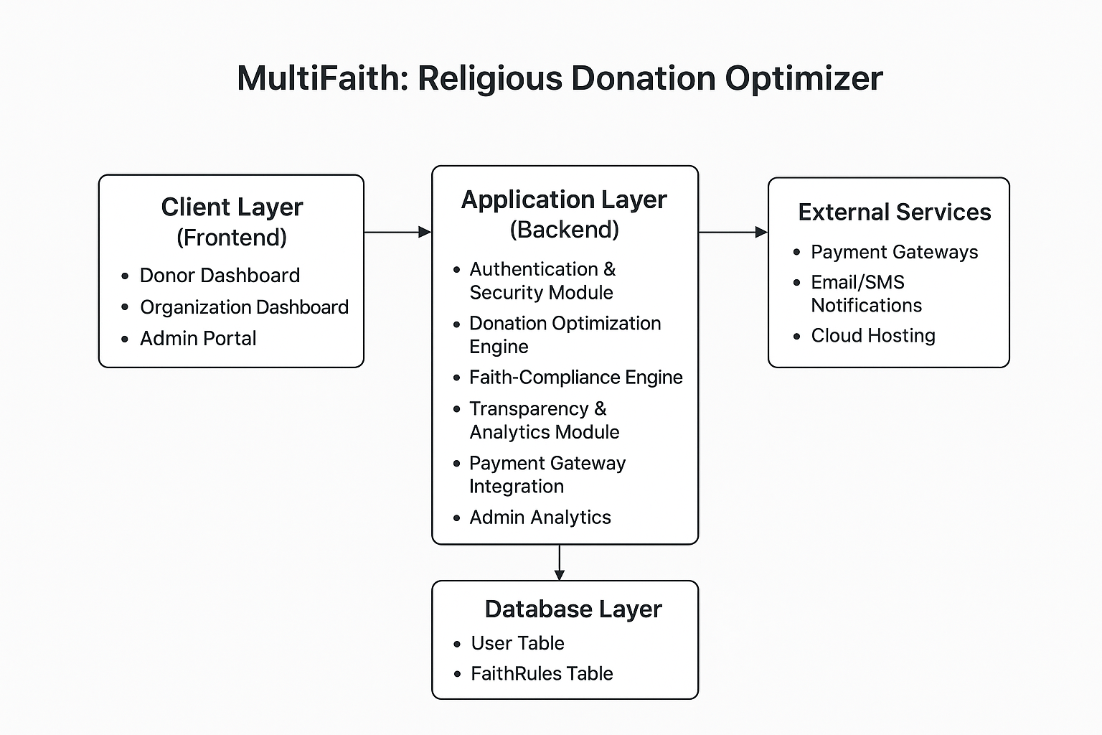
- Figma Diagrams (System Design)
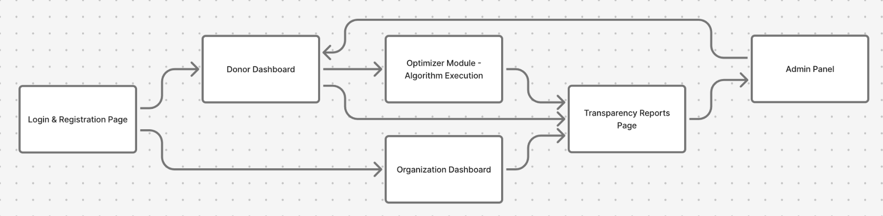
- Login & Registration Page → entry point for donors and organizations
- Donor Dashboard → cause/faith selection, donation entry, optimization results
- Organization Dashboard → track donations, request funds
- Transparency Reports Page → visual reports (impact, allocation by cause/faith)
- Admin Panel → manages donations and monitors optimization engine

Results Section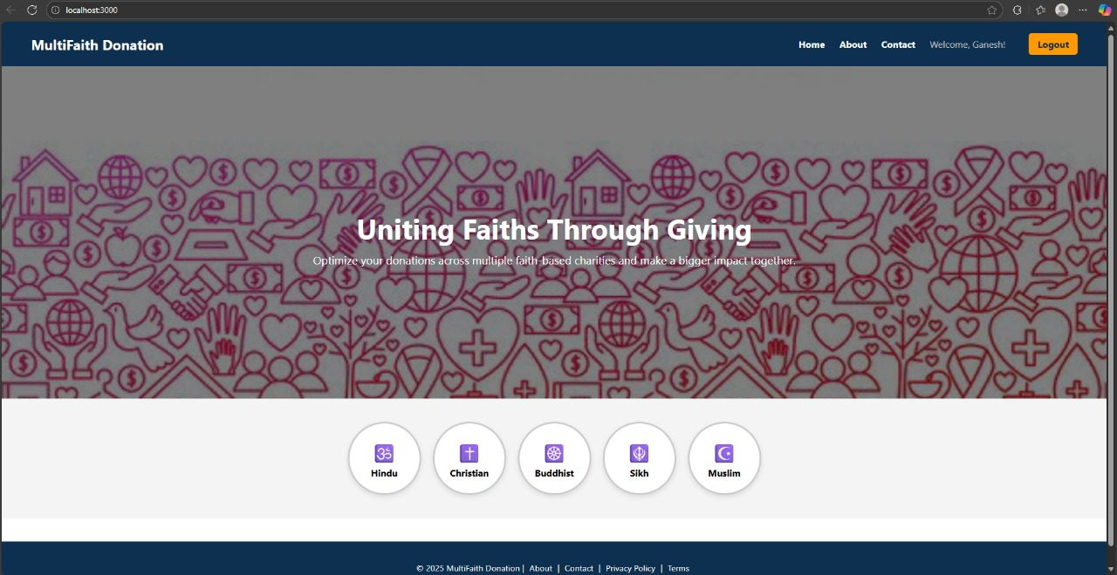
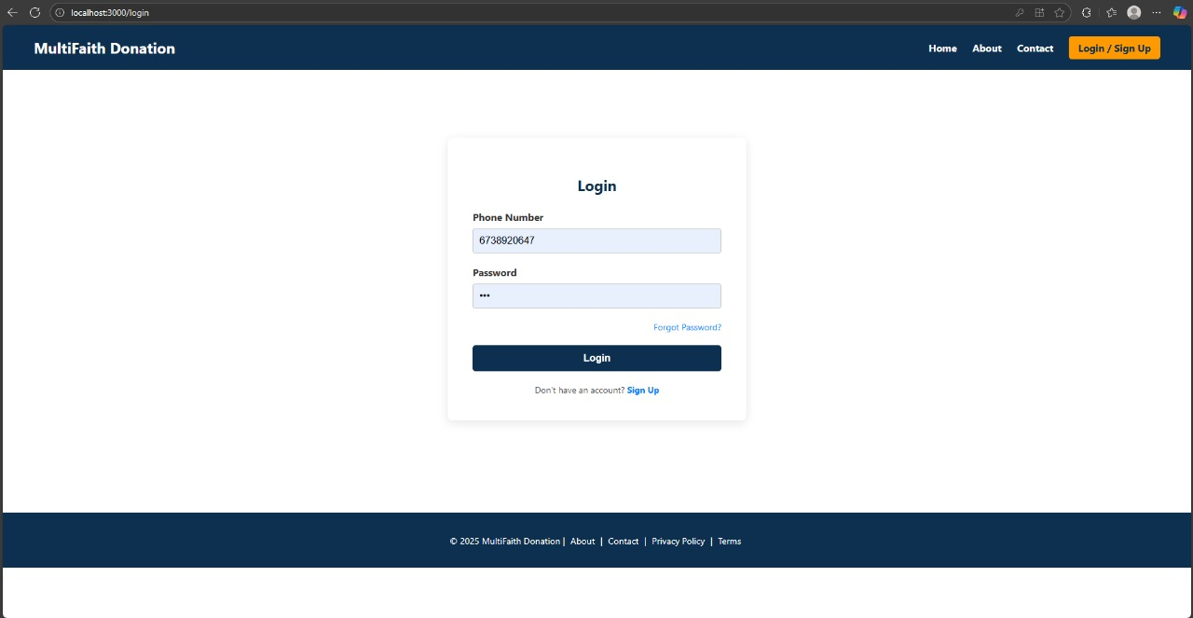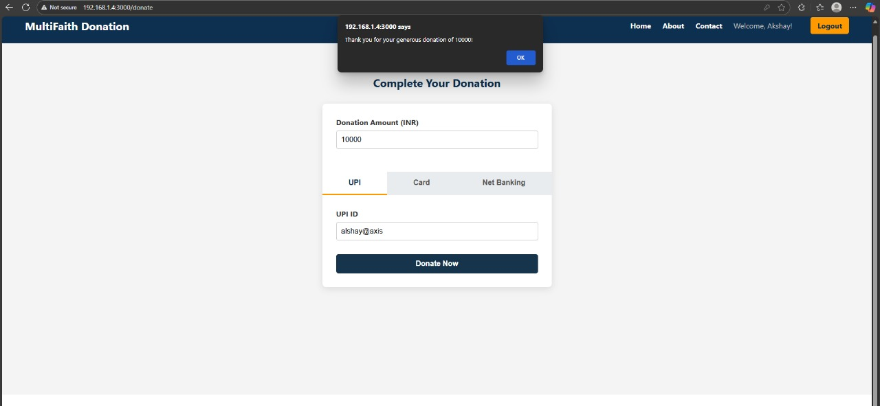

- Conclusion
The Multifaith Donation Optimizer project successfully demonstrates how technology, ethics, and faith can coexist within a unified digital ecosystem for global philanthropy. It bridges the long-standing divide between faith-based and secular giving by providing an intelligent, transparent, and inclusive platform that ensures fairness and maximized social impact. Through this project, we aimed to build not only a digital donation system but also a symbol of interfaith cooperation and human unity.
The platform empowers donors to make informed and balanced contributions while enabling organizations to manage funds efficiently and transparently. Using optimization algorithms such as linear programming and weighted allocation, the system ensures that donations are distributed equitably based on priority, impact, and donor intent.
Developed with HTML, CSS, and JavaScript, the prototype emphasizes simplicity, usability, and scalability. The integration of a transparency dashboard and faith-based filters makes the system both user-friendly and culturally sensitive, while maintaining the highest level of accountability in digital philanthropy.
- References

- United Nations. (2015). Transforming Our World: The 2030 Agenda for Sustainable Development. United Nations General Assembly.
Available at: https://sdgs.un.org/goals
- World Bank. (2018). Atlas of Sustainable Development Goals 2018: From World Development Indicators. Washington, DC: World Bank.
- Koenig, H. G. (2012). Religion, Spirituality, and Health: The Research and Clinical Implications. ISRN Psychiatry, 2012, 1–33.
- Campbell, H. A., & Tsuria, R. (2021). Digital Religion: Understanding Religious Practice in Digital Media. Routledge.
- Mishra, S., & Mehta, A. (2020). Digital Platforms for Knowledge Dissemination on Sustainable Development. International Journal of Information Management, 50, 273–281.
- Bruck, P. A., Motiwalla, L., & Foerster, F. (2012). Mobile Learning with Micro-Content: A Framework and Evaluation. Proceedings of Bled eConference, 593–607.
- Glahn, C., Specht, M., & Koper, R. (2009). Smart Indicators on Learning Interactions. Journal of Educational Technology & Society, 12(2), 54–65.
- Sahlberg, P. (2016). The Global Educational Reform Movement and Its Impact on Digital Learning. In Digital Technologies in Education (pp. 128–145). Springer.
- Tech4Good Initiative. (2020). Technology for Social Impact: Harnessing Digital Innovation for the Common Good.
- Pew Research Center. (2021). Faith in Digital Spaces: How Religion and Technology Intersect. Washington, DC.
- Express.js Foundation. (2023). Express.js — Fast, Unopinionated, Minimalist Web Framework for Node.js.
Available at: https://expressjs.com
- MongoDB Inc. (2023). MongoDB Documentation: The Developer Data Platform.
Available at: https://www.mongodb.com/docs/
- Mozilla Developer Network (MDN). (2024). HTML, CSS, and JavaScript Web Documentation.
Available at: https://developer.mozilla.org/
- Hug, T. (2007). Didactics of Microlearning: Concepts, Discourses, and Examples. Waxmann Publishing.
- Salomon, G. (2014). Technology and Education — Between Chaos and Order. In Education and Technology: Critical Perspectives, Possible Futures (pp. 3–20). Springer.

